**INNOVATIVE PROJECT**

TITLE : HOME AUTOMATION AND ENERGY MONITORING

**“This idea is for the enhancement of our house, since home is where we seek pilgrimage.”**

**ABSTRACT** : The project has two parts:

1. **HOME AUTOMATION :**

* **DESCRIPTION :** This section of the project revolves around the implementation of Google Assistant based voice command service into our home appliances. This application includes Google assistant along with Adafruit server and IFTTT service and we’re also working on an android application which has the capability to get direct access to Adafruit server to use it as an alternate of controlling the appliances
* **COMPONENTS :**

1. Node MCU(ESP8266)[INR 800 ]
2. Relay Module[INR 200]
3. Android Phone[Supporting MQTT Dashboard and Google Assistant]

* **DESIGN :** 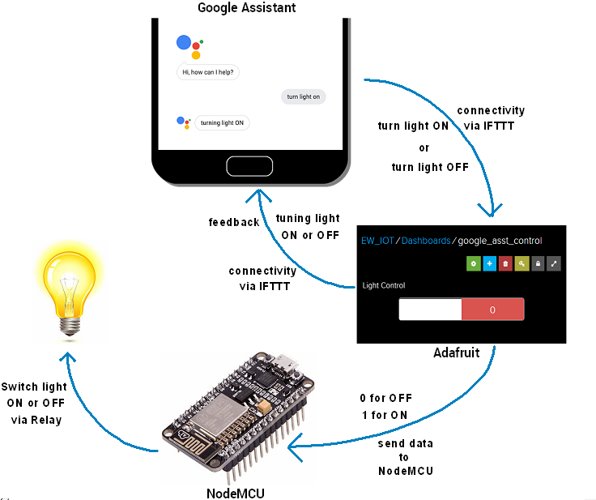
* **METHODOLOGY :**

1. Creating Adafruit account and setting up your Dashboard.
2. Create user interface to control light On-Off. We used ‘0’ (OFF) and ‘1’ ON toggle button in the Dashboard.
3. IFTTT is a free web-based service to create chains of simple conditional statements called applets.
4. We used IFTTT to use google assistant service and Adafruit service in chain. So, when I use google assistant to control light of my home by saying Ok google, turn the light ON or OFF. Then IFTTT interpret the message and can send it to Adafruit’s dashboard as an understandable command to the created feed ( ON/OFF).
5. Setting up IFTTT account and select Google Assistant Service in the +this section and configure it according to the Voice commands you’ll be sending.
6. Select the Adafruit service in +that section and complete your action fields i.e.
7. When we Google Assistant on mobile phone to give command as “OK Google, Turn On the Light “ the applet created in IFTTT will fetch the command and send data ‘1’ to the Adafruit feed which will in turn trigger the event on Adafruit dashboard which is continuously monitored by the Node-MCU. So, now the Microcontroller will take actions as per the data change on our Adafruit dashboard. So it will turn the light ON.
8. We’ll also create an Android Application with the help of MIT App Inventor and Android Studio to directly switch ON/OFF the appliances even from this custom made Android app.

Second part is :

**2 . ENERGY MONITORING :**

* **DESCRIPTION :**

1. In this project we can monitor our electricity uses from anywhere in the world and get SMS/E-mail when energy consumption reaches to a particular value.
2. In this project we make a Smart Energy meter using Arduino and Node-MCU which will send a SMS/Email of Electricity bill and can also access Monitoring the energy from anywhere in the world.
3. We'll use the help of IFTTT platform to SMS/E-mail notifications. We will also use MQTT Dashboard Android App to monitor our Energy uses and interface of Adafruit server

* **COMPONENTS :**

1. Arduino UNO[INR 900]
2. Node MCU(ESP8266)[INR 800]
3. Current sensor(ACS712-30 Amp)[INR 190]

* **DESIGN :**
* **METHODOLOGY :** 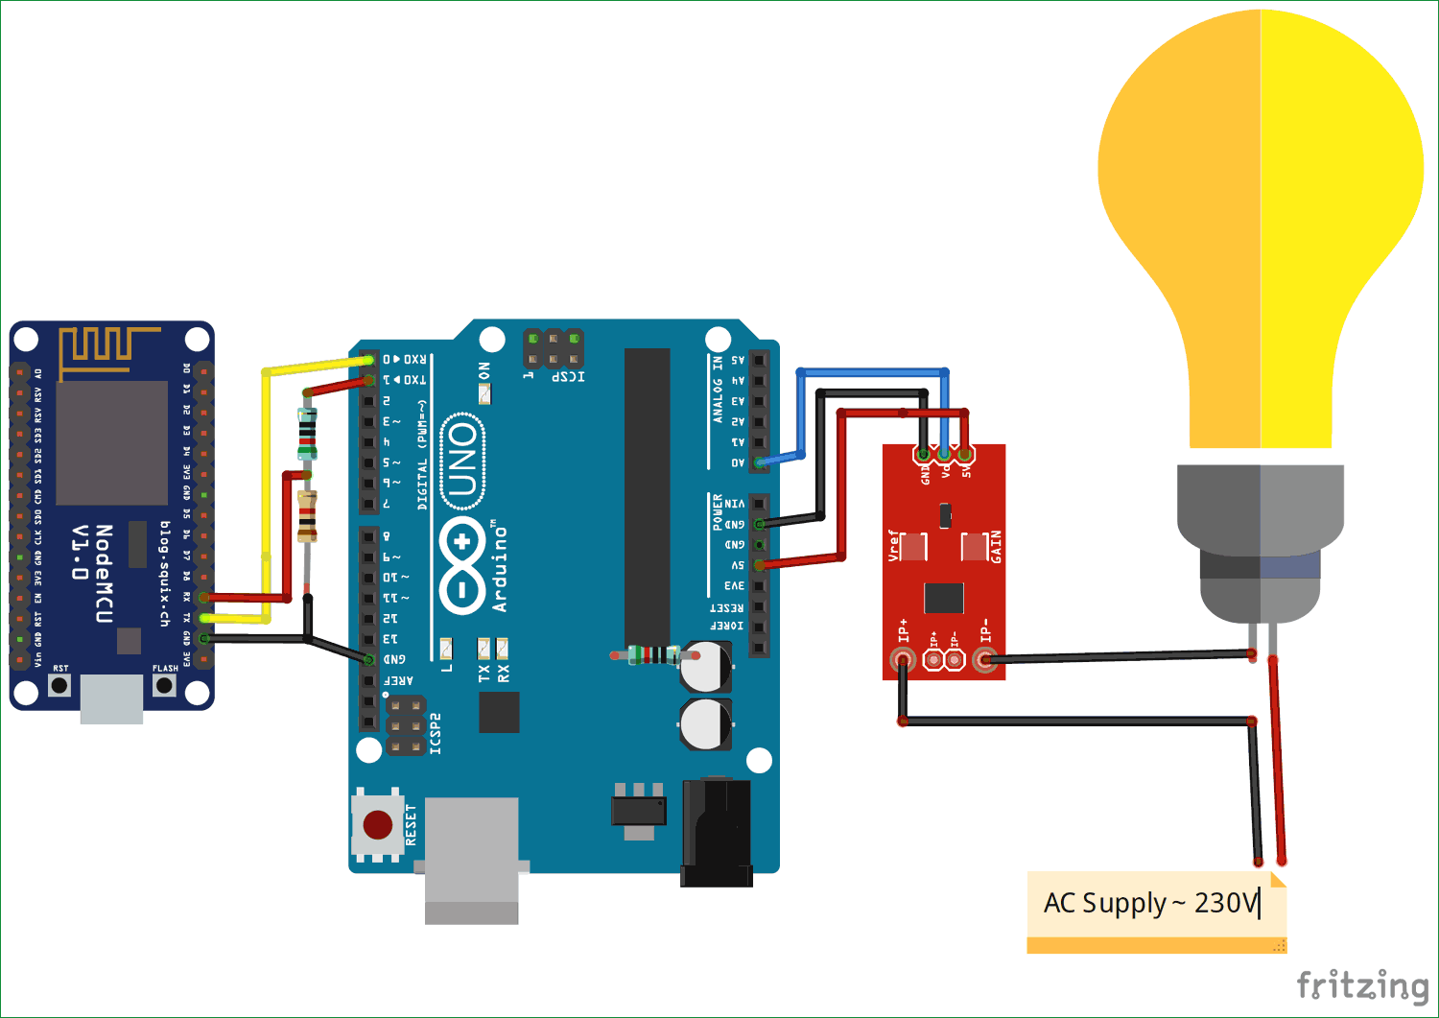

1. Setting up of Adafruit Account : Create an Adafruit account by logging in Adafruit IO followed by creating a new dashboard, Then we click on to gauge to display Energy uses level and hence fill the maximum and minimum values for modifying the gauge display and create feed to display Bill.
2. Applet creation in IFTTT: With the creation of IFTTT applet we can use the service of Adafruit and Gmail in chain so that whenever a certain amount of bill is exceeded we'll receive an Email/SMS describing the amount.for that after creating a New Applet we choose Adafruit Service in the +this option and create a required trigger, and in the +that section we select G-mail service and login using our G-mail credentials and Complete the mandatory action fields.

**APPLICATION FOR SOCIETY :**

1. **Savings:** Smart thermostats and smart light bulbs save energy, cutting utility costs over time. Some home automation technologies monitor water usage, too, helping to prevent exorbitant water bills. Certain devices even offer rebates.
2. **Convenience:** Because home automation technology performs rote tasks automatically, end users experience great convenience. Lots of smart gadgets are compatible with one another, and you can set different triggers between devices to automate regular home processes. For instance, you could set your smart locks to turn on your smart lighting when you unlock the front door.
3. **Control:** Consumers also choose smart home devices to better control functions within the home. With home automation technology, you can know what’s happening inside your home at all times.
4. **Comfort:** Some people use smart technology to record shows or to play music throughout the home. Connected devices can also help create a comfortable atmosphere—they provide intelligent and adaptive lighting, sound, and temperature, which can all help create an inviting environment.
5. **Peace of Mind:** Finally, many consumers invest in home automation technology for peace of mind. A new mom or dad can check on their little one thanks to smart cameras and other technologies. Or, if you can’t remember whether you closed the garage after you left, you can verify remotely with an app.

**FUTURE USE :** Home of the future is a space for the digital natives. With the invention of lots of automation technologies featuring IOT and AI, home automation has become a reality. One can implement several of their tasks with just a single command of verbal instructions. These technologies can used to build fully functional home automation system and control smart home devices including smart lights, connected thermostats, and appliances.